**LAB REPORT NO 05**



**Systems Programming (CSE 302L)**

**Submitted By: Naveed Ahmad**

**Registration No: 22PWCSE2165**

**Section: B**

“On my honor, as student of University of Engineering and Technology, I have neither given nor received unauthorized assistance on this academic work”

Signature: __________

Date: Nov 02, 2024

Submitted To: Engr. Madiha Sher

**Department of Computer Systems Engineering**

**University of Engineering and Technology**

**Task 1:** Implement the cp command. Your program shall take the name of the files

(source and destination) as input from the command line.

Code:

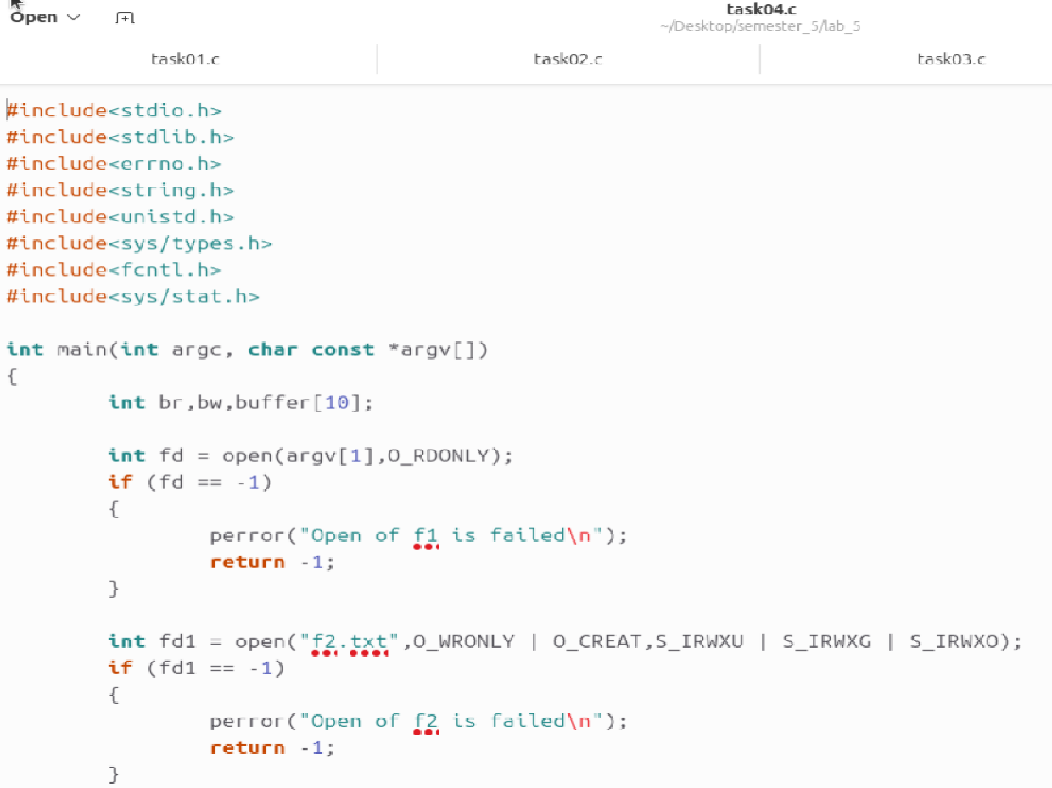

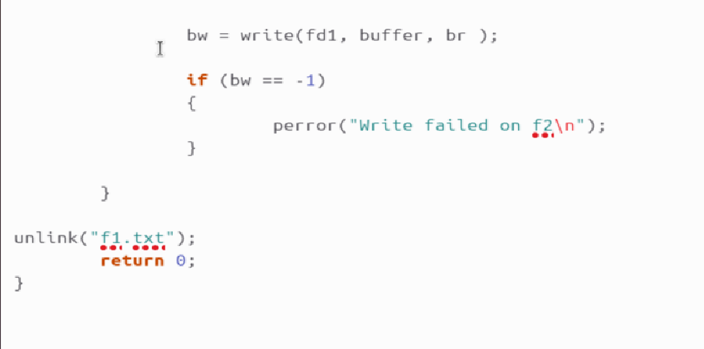

Output:

**Task 2:** Implement rm command.

Output:



**Task 3:** Implement wc command that displays the number of lines, number of

words and size of file. Take the name of the file as input from the user.

Code:

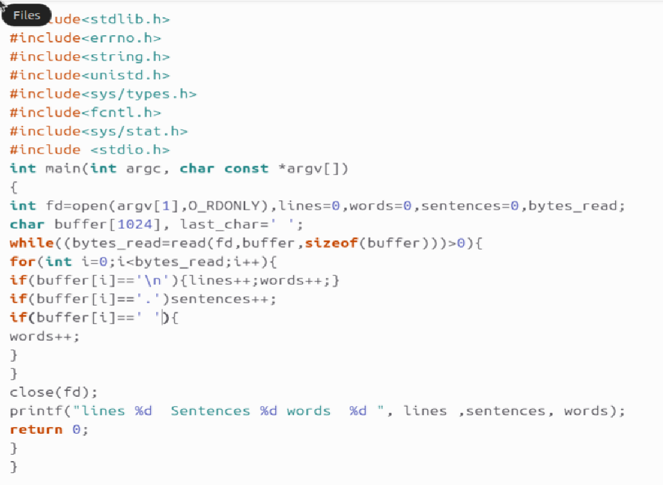

Output:



**Task 4:** *Implement a function that reads a single line from a file and returns the*

*number of bytes in the line that was read. Additionally, the function should store the*

*contents of the line in a buffer. In the main function, repeatedly call this line-reading*

*function until the end of the file is reached.*

Code:



Output:

